"I am Robot" Lesson and Contest

Subject:  Related Subjects: | Grade Level(s):  Length of Lesson: | Type: Inquiry / Design / Project  Keywords:

Lesson Overview
Use this section to describe at a high level what the lesson is. Should be no more than 3-4 lines.

Lesson Focus
What is the central question or phenomenon being investigated? What problem are they trying to solve?

Lesson Objective(s) | To familiarize student with how robots “think”, students will work on 3 team activities. For the first activity, the teams will use students as robots to understand how programming a robot works. For the second activity, the students will construct simple robots to further their understanding of robotic programming. For the final activity, students will build series circuits to gauge an understanding of sensors used in robotic structures.

Lesson Timing

5 minutes | Introduce the Lesson
30 minutes | ...

Materials | - Material 1 (# per student, per group of # students, per class)
Instructor Prep | - Step 1
Related Resources | - List related lessons/ppts etc available from USC or outside, trusted orgs

Lesson Plan

Introduction
Introduce students to the learning goals and make connections to past and present learning experiences. Stimulate interest and prompt students to identify their own questions about the topic. This can link the lesson to real world examples, introduce associated STEM careers, and assess their prior knowledge on the topic.

- Step 1

Procedure
- Activity 1- Human robot activity
- Divide the students into teams and have each team pick a student to be the robot.
- Students will create an outline of tasks the “robot” must complete.
Example: a. Walk across room to retrieve a book
b. Throw something away in the trashcan
c. Write a letter on the board
3. Each team will now write a program to control a “robot” from another group. A program contains the detailed and specific instructions telling the robot what to do (see example below). Have the teacher collect the program and redistribute to randomize the program given to each team.
Example: a. Move right foot forward other foot and stop.
b. Shift weight to right foot
c. Life left foot 6 inches off the ground
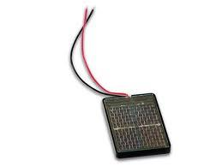

- Build a robot activity
1. Divide the students into teams and have the teams create a new outline of tasks for the robot to complete.
2. Students will build a tube car that will be connected to wire controllers.

Tube Car Robot Construction
- To form the wheel-axle, insert one axle wood dowel into 2 small wheels (cardboard tube rolls with ends covered by paper) and the other axle wood dowel into the longer wheel.
- Attach motors to the chassis (foam board with V’s) using binder clips. The stem of the motors should be over the V so it can spin when wired up. The binder clips should be as close to foam board as possible to prevent it from touching the wheels.
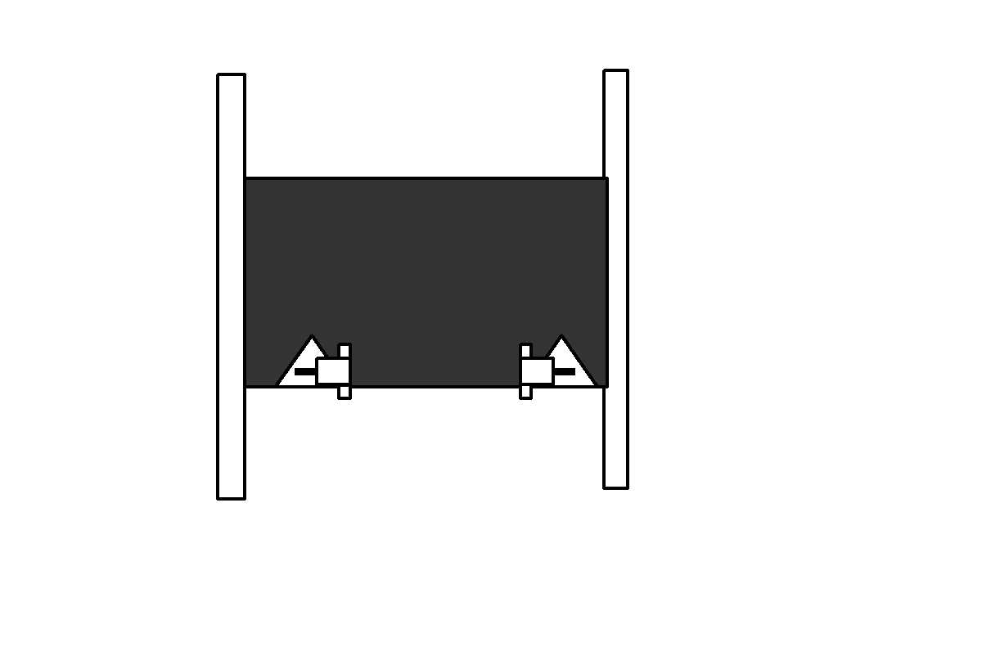
- Attach the wheel-axle with two small wheels to the side of the chassis with motors using rubber bands at the ends in which the dowels on the chassis and the wheel-axle overlap. Make sure that 1. Dowel wheel-axle should be underneath the chassis dowel 2. Wheels need to be lined up centered over the V’s
- Pull rubber bands on the wheel over the stem of the motor that is in front of it.
- Attach the wheel-axle with longer wheels to the other side of the chassis.
- Use the clothespins on the controller to clamp the outside red wire on the switch to the outside black wire on the switch; then both wires to the green wire of the one of the motors.
- Use the clothespins on the controller to clamp the inside red wire on the switch to the inside black wire on the switch; then both wires to the yellow wire of the same motor as above.
- Repeat for the motor and switches on the other side.
- Test with batteries. This is your tube car robot!

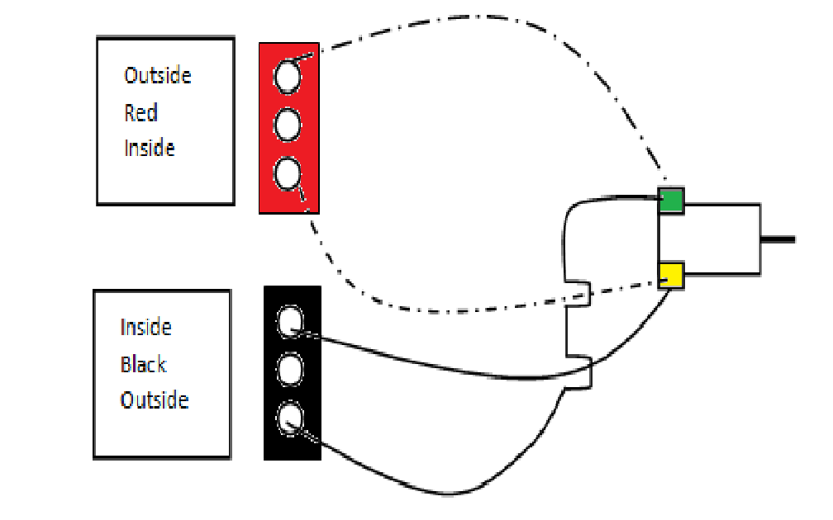
3. Each team will write a new program to control a robot from another group.
Example: a. Turn on reverse switch for left wheel for 3 seconds.
b. Turn on forward switch for right wheel for 2 seconds.
4. Teams will test their created program on their robot first to make sure it is possible.
5. Teams will adjust their program after testing.
6. Teams will launch their robots at the same time. The team whose robot accomplishes the task first wins.

Note:
    - A wire is “active or hot” when the switch is pointed way from the post where the wire is connected.
    - Two wires going to the same wire on the motor should NEVER be active at the same time or the batteries will get hot and smoke.
    - You may need to rearrange the wire connections motors to get them to go in the direction you want them to go when the switches are in the same direction.

- Understanding sensors using series circuits
- Connect a red wire to the long leg of an LED
- Connect a black wire to the short leg of an LED
- Twist the black wire from a battery holder to the other end of the black wire connected to the LED
- Toggle Switch – Is like a general sensor that causes action when turned on
  - Connect the red wire from the LED to one of the outer prong of the three prong switch and twist.
  - Connect the red wire from 2 AA battery holder to the center prong.
  - Move the switch and observe what happens
- Normally open pushbutton switch (red) – Is like a touch sensor that causes action to start when pressed
  - Connect the red wire from the LED to one of the prongs of the switch
  - Connect the red wire from the battery holder to the other prong of the switch
  - Press the button and observe what happens
- Normally closed pushbutton switch (black) – Is like a touch sensor that causes action to stop when pressed
  - Connect the red wire from the LED one of the prongs of the switch
  - Connect the red wire from the battery holder to the other prong of the switch
  - Press the button and observe what happens
- Solar cell switch –Is like a light sensor that causes action when light is detected
  - Twist red wire from LED to red wire of solar cell
  - Twist black wire from LED to black wire of solar cell
  - Put solar cell in direct light (florescent lights usually don’t work) and observe what happens

Wrap-up
End the lesson with some final discussions about what students designed/discovered. Connect their activity back to the focus question/problem, real world examples, and STEM careers.

Also include notes about any special cleanup considerations

Lesson Background for Teachers

Suggested Real-World STEM Connections
- List possible related Role Models in STEM (with details and links to more reading). Give suggestions for examples of scientists/engineers who are from underrepresented groups in STEM in related careers.
- List related real-world engineering problems and examples

Lesson Variations and Options
Include descriptions of alternative methods or ways to present things.

Explanation
Describe the background concepts and explanations behind the lesson. This can be more in depth than a teacher/instructor would actually share with students.

Key Concepts and Vocabulary
- Word 1: Grade Appropriate Definition
- Word 2: Grade Appropriate Definition

Safety Notes
- Safety instruction

